Aethoria: Finalverse Legends

Creating a new intellectual property for Finalverse that draws inspiration from the spirit of adventure and rich storytelling found in fantasy epics can set the foundation for a unique and engaging Metaverse experience. Here's a story concept and key characters for Finalverse, designed to captivate users with a narrative that balances familiarity with innovation:

**Finalverse IP: "Aethoria: Finalverse Legends"**

**Background Story:**

The realm of Aethoria, a lush and diverse world, thrives through the harmonious coexistence of its six elemental nations: Ardentia (Fire), Zephyria (Air), Terraqua (Earth), Aquoria (Water), Luminara (Light)and Halitus(Spiritus). Each nation is empowered by a sacred crystal that channels the elemental energy, maintaining balance and prosperity.

An ancient prophecy foretells the arrival of a dark force known as the "Voidshroud," which seeks to disrupt this balance and engulf Aethoria in chaos. The prophecy also speaks of the "Final Guardians," a group of diverse heroes chosen by destiny to wield the power of the elemental crystals and restore harmony to the world.

Aethoria: Finalverse Legends - Background Story

In the beginning, the realm of Aethoria emerged from the fabric of the cosmos as a beacon of harmony. Five great elemental nations arose, each a manifestation of the world's intrinsic forces. Ardentia, the kingdom of flame, was born from the world's fiery heart. Zephyria, the domain of the skies, soared above with its citizens walking among the clouds. Terraqua, the bastion of earth, stood firm with its colossal mountains and verdant forests. Aquoria, the sanctum of the seas, flowed with the ancient rhythm of tides. Luminara, the realm of radiance, shone with an ethereal light that pierced through the darkest voids.Finally, Haritus, the spiritual kingdom, governs the flow of life, the purification and rebirth of the soul, and the elevation of consciousness.

At the core of each nation thrived a sacred crystal—a conduit of pure elemental energy. These crystals were not only the source of each nation's strength but also the pillars that sustained the balance of Aethoria. The Flame Crystal of Ardentia blazed with an unyielding fire that warmed and protected. The Wind Crystal of Zephyria whirled in the high towers, guiding the currents and the breath of life. The Earth Crystal of Terraqua pulsed with the world's vitality, giving rise to lush abundance. The Water Crystal of Aquoria ebbed and flowed with the wisdom of the ages. The Light Crystal of Luminara cast away the shadows, a beacon of hope and guidance.The crystals of Haritus channel soul energy, connect the consciousness of all life, and promote deep understanding and harmonious coexistence between the elemental nations.

For eons, the harmony of Aethoria was unchallenged, its people living in a utopia blessed by the elements. But the threads of peace began to unravel as whispers of an ancient prophecy echoed through the halls of time. It told of the Voidshroud, a malevolent force that would emerge from the depths of the cosmos, seeking to engulf the world in darkness and discord. It was said that this dark force would disrupt the elemental flow, twisting the land into a shadow of its former self.

As the prophecy loomed over Aethoria, the sages and oracles of the elemental nations sought to understand the means to avert such a catastrophe. They delved into the ancient texts and consulted the stars, only to realize that the fate of Aethoria rested not in the hands of the mighty, but in the embrace of destiny itself.

The prophecy spoke of the Final Guardians, a band of heroes each bearing the heart of an element. These champions would be chosen by destiny to wield the power of the elemental crystals, standing against the tide of the Voidshroud. It was foretold that their unity would be Aethoria's salvation, their courage its shield, and their resolve the blade that would restore harmony.

The signs of the prophecy's fulfillment began to manifest as the Voidshroud's influence crept into the world. Shadows lengthened, and the air grew heavy with an unspoken dread. The elements themselves stirred with unrest, their energies waning under an unseen burden. It was then that the crystals called out into the void, seeking those who would rise to become the Final Guardians.

From the fiery forges of Ardentia came Pyra Blaze, a warrior whose spirit burned as fiercely as the eternal flames of her homeland. Zephyr Windblade answered the call on the gusting currents above Zephyria, his wit as sharp as the winds he commanded. Terra Earthwarden emerged from the ancient groves of Terraqua, her wisdom as deep as the roots that bound her to the earth. Aqua Wavefletcher rose from the depths of Aquoria, her resolve flowing like the ceaseless rivers of her realm. And from the illuminated spires of Luminara came Lux Lightshield, a paladin whose radiance shone with the purity of dawn.Finally, from the secluded temple of Halitus, the land of souls, the call of the spirit world touched Thor Soulsong's heart. Her calmness and inner strength are like the silent river of Haritus, guiding lost souls to find the light even in the darkest of moments.

Together, these six heroes embarked on a quest that would take them to the farthest reaches of Aethoria and beyond. United by destiny, they would face trials of fire, wind, earth, water, and light. They would forge alliances with creatures of legend and beings of the ethereal plane. Their journey would be one of self-discovery, as they unearthed hidden truths and harnessed the full potential of the elemental crystals.

The epic tale of their struggle against the Voidshroud would be etched into the annals of Aethoria—a tale of bravery, sacrifice, and the enduring power of unity. "Aethoria: Finalverse Legends" thus begins, with the fate of a world hanging in the balance, and the dawn of an adventure that would transcend the very essence of the elements themselves.

**Key Characters:**

* **Pyra Flameheart (Blaze)** – The fiery and fearless warrior from Ardentia, guardian of the Flame Crystal. Her courage and combat skills are unparalleled, and her passion inspires those around her.

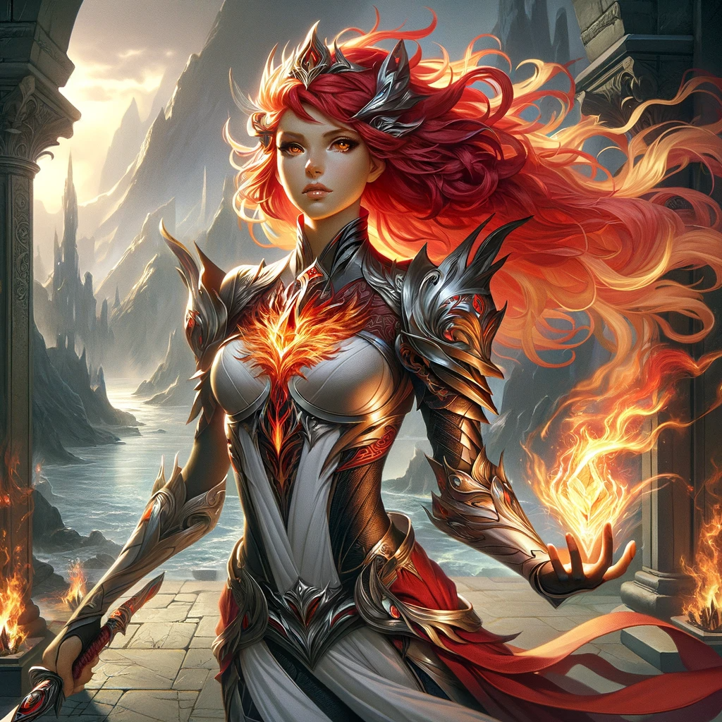

image of Pyra Flameheart, the fiery and fearless warrior from Ardentia, guardian of the Flame Crystal. Her appearance reflects her courage and combat skills, and her passionate spirit that inspires those around her.

* **Zephyr Galewind (Windblade)** – The enigmatic rogue from Zephyria, guardian of the Wind Crystal. With his swift agility and sharp wit, he navigates the skies and outmaneuvers his foes with ease.

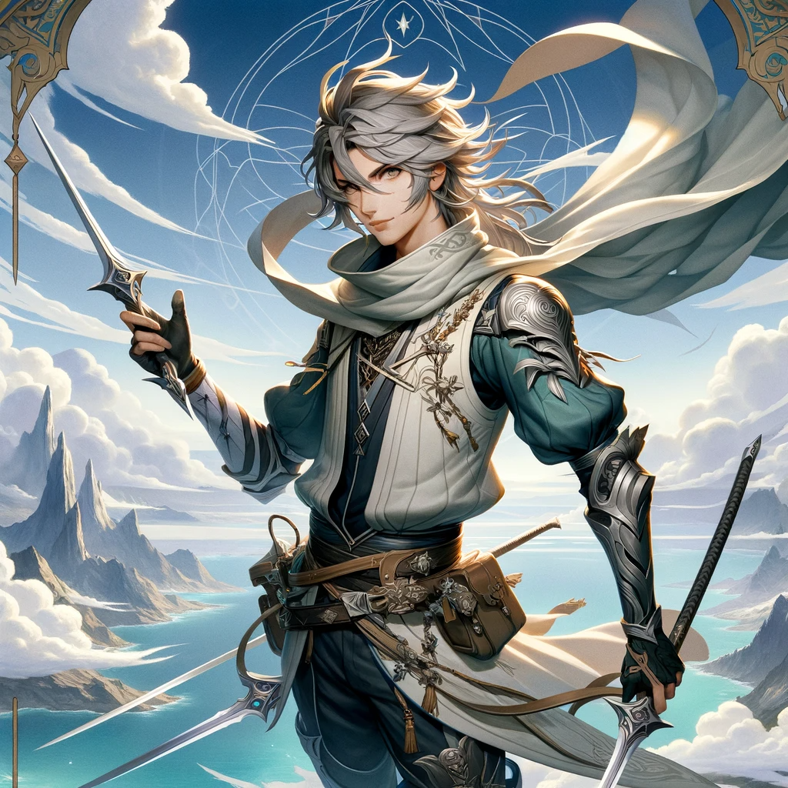

image of Zephyr Galewind, the enigmatic rogue from Zephyria, guardian of the Wind Crystal. His portrayal captures his swift agility, sharp wit, and mastery of the skies.

* **Terra Stonebloom (Earthwarden)** – The stoic and wise mage from Terraqua, guardian of the Earth Crystal. Her deep connection to nature allows her to harness the land's might and mend wounds with her healing arts.

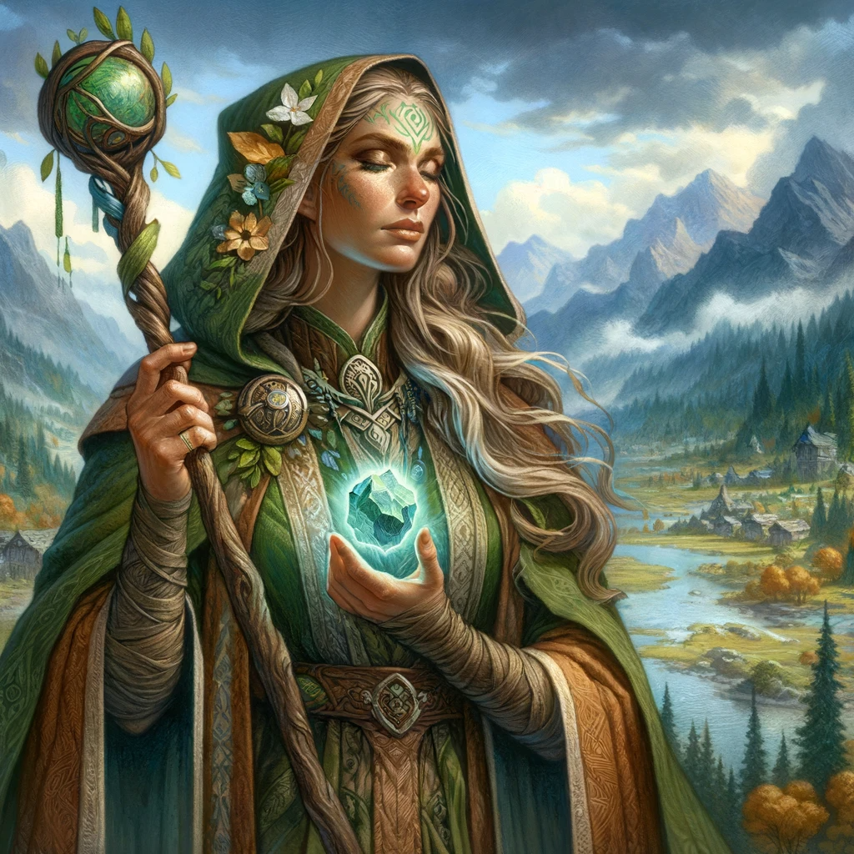

image of Terra Stonebloom, the stoic and wise mage from Terraqua, guardian of the Earth Crystal. Her depiction reflects her deep connection to nature and her abilities to harness the land's might and perform healing arts.

* **Aqua Riverstride (Waveflectcher)** – The serene and agile ranger from Aquoria, guardian of the Water Crystal. With her bow and command over aquatic creatures, she is a formidable ally in any battle.

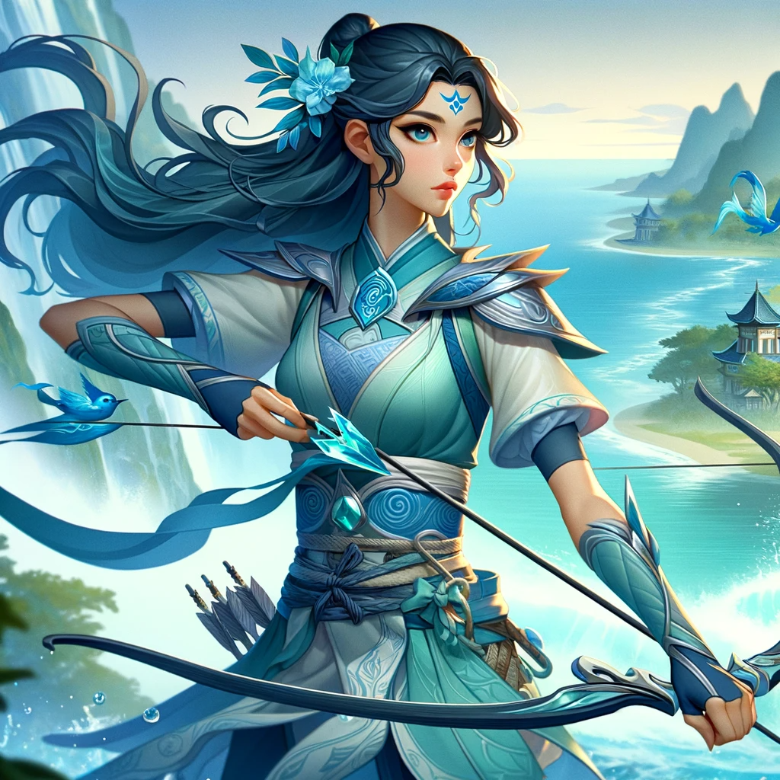

image of Aqua Riverstride, the serene and agile ranger from Aquoria, guardian of the Water Crystal. Her portrayal captures her connection with water and her prowess as a skilled ranger.

* **Lux Starwhisper (Lightshield)** – The kind and noble paladin from Luminara, guardian of the Light Crystal. His strategic prowess and light magic provide guidance and protection to the group.

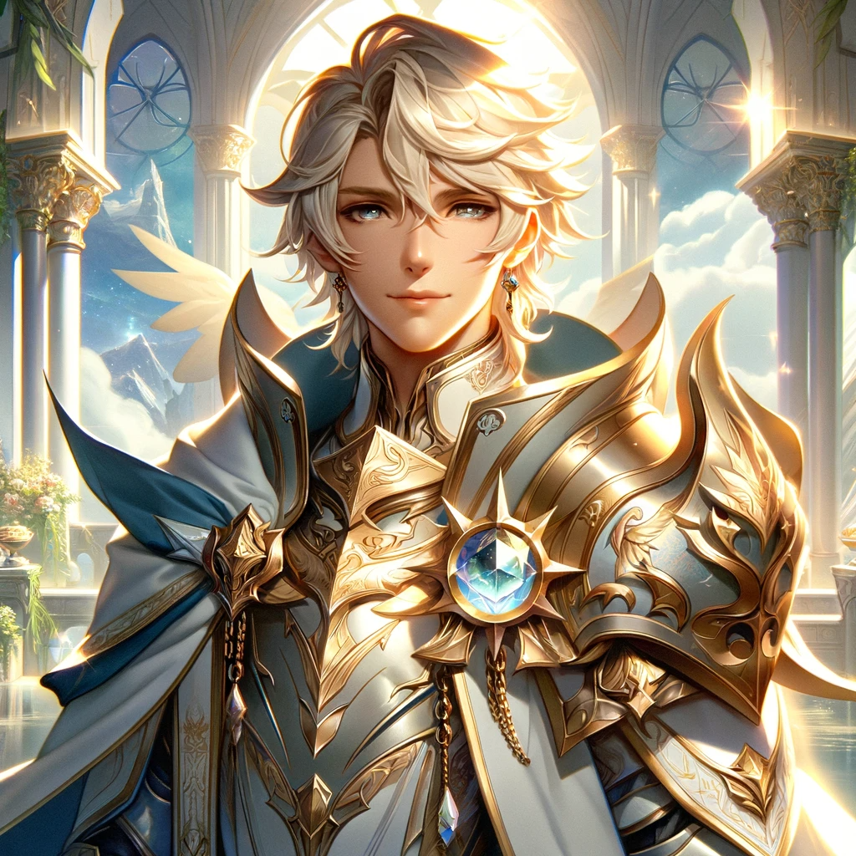

image of Lux Starwhisper, the kind and noble paladin from Luminara, guardian of the Light Crystal. His portrayal reflects his role as a protector and his mastery of light magic.

* **Saul Gorthuil(Lingl)** - an elf from Halitus, guardian of the Spirit Crystal. Her psychic eyes can see into life, and her flute can awaken souls. (Alias: Saul Lingl - Saul Lingl)

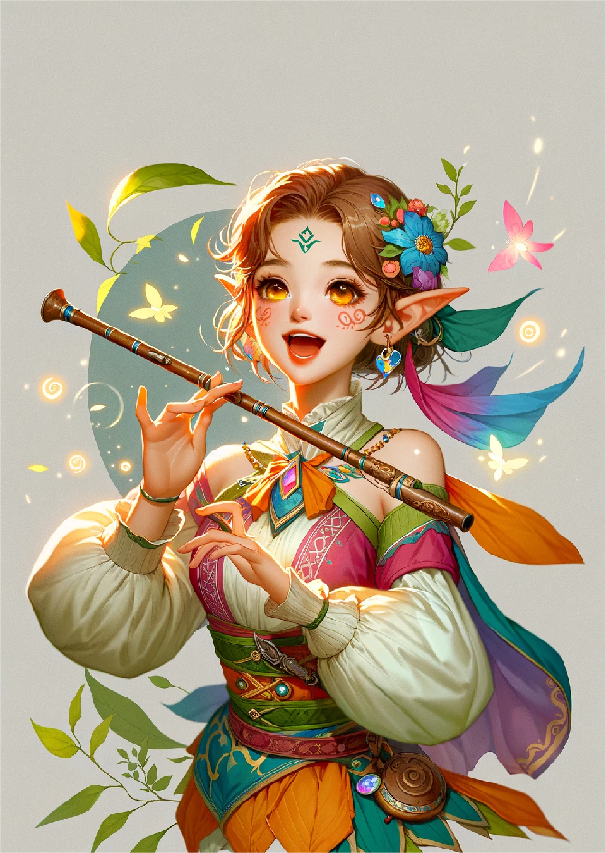

Image of Sol Soulge. She has a lively appearance, but is very independent on the inside. Her singing invisibly weaves a protective barrier against the dark forces that seek to tear apart the harmony of the world.

**Plot Summary:**

As the Voidshroud begins to cast its shadow over Aethoria, disrupting the flow of elemental energies, the five heroes are summoned by a mysterious force to the ancient Nexus, a sacred site where the boundaries between the elemental nations converge. Here, they are entrusted with the elemental crystals and embark on a quest to prevent the Voidshroud from consuming their world.

Their journey is one of discovery, as they explore the vast landscapes of Aethoria, from the volcanic depths of Ardentia to the soaring heights of Zephyria. Along the way, they forge alliances, uncover hidden truths about their world, and learn to master the power of the crystals through personal growth and unity.

Each hero faces challenges that test their beliefs, forcing them to evolve and embrace their roles as the Final Guardians. As they journey deeper into the darkness of the Voidshroud, they encounter a variety of creatures, allies, and adversaries, each with their own stories that weave into the rich tapestry of Aethoria's lore.

In the climactic battle, the heroes confront the source of the Voidshroud, revealing a complex narrative of betrayal and redemption. With the fate of Aethoria hanging in the balance, the Final Guardians must channel the full potential of the crystals to restore light to the world and usher in a new era of peace.

**Title: Aethoria - Finalverse Legends**

**Prologue: The Prophecy of Balance**

* Introduce Aethoria, a world where harmony is maintained by the elemental crystals.
* Present the prophecy predicting the rise of the Voidshroud and the emergence of the Final Guardians.

**Chapter 1: The Flame of Ardentia**

* Introduce Pyra Flameheart, a warrior with a fiery spirit, during a festival in Ardentia.
* Pyra encounters a mysterious anomaly affecting the Flame Crystal and receives a vision guiding her to the Nexus.

**Chapter 2: Whispers of the Wind**

* Introduce Zephyr Galewind, a cunning rogue, as he outwits opponents in the floating arenas of Zephyria.
* Zephyr discovers the Wind Crystal's weakened state and is led by a strange gust towards the Nexus.

**Chapter 3: Terra's Resolve**

* Introduce Terra Stonebloom in the great library of Terraqua as she senses the Earth Crystal's disturbance.
* Terra encounters ancient texts about the Nexus and sets out on a journey following cryptic clues.

**Chapter 4: Aqua's Odyssey**

* Introduce Aqua Riverstride, safeguarding the rivers of Aquoria, as the Water Crystal's power wanes.
* Aqua receives a call from the sea creatures to seek the Nexus and embarks on her quest.

**Chapter 5: Lux's Illumination**

* Introduce Lux Starwhisper during a solar alignment ceremony in Luminara as the Light Crystal dims.
* Lux experiences a vision of the Nexus and begins his pilgrimage to find it.

**Chapter 6: The Melody of Haritus**

* Introducing spiritual songs, she played her flute in the temple with beautiful and sacred melodies that could soothe the most restless soul.
* Thor witnessed a phantom, a vast hub at its center, surrounded by representatives of the elemental nations, while a mysterious darkness was approaching, threatening all of Isolia, with the wisdom of her prophets and the guardians of Courage, embark on the journey to the hub.

**Chapter 7: The Nexus of Fate**

* The heroes meet at the Nexus, where they're chosen by the crystals and form an uneasy alliance.
* They learn of their destiny as the Final Guardians and set out to understand their new powers.

**Chapter 8: The Journey Commences**

* The group ventures into the Verdant Wilds of Terraqua, facing mythical beasts and natural obstacles.
* They bond over campfire tales, revealing their backstories and motivations.

**Chapter 9: Shadows of Ardentia**

* The Guardians confront the Voidshroud's minions in the scorched lands of Ardentia, protecting Pyra's homeland.
* They witness the destructive potential of the Voidshroud firsthand.

**Chapter 10: Secrets of the Zephyrian Skies**

* In Zephyria, the group navigates aerial cities to find clues about the Voidshroud's origins.
* Zephyr confronts his past and gains the trust of the team.

**Chapter 11: The Earth's Whisper**

* In Terraqua, Terra leads the Guardians to hidden sanctuaries where they learn crucial lore.
* The group strengthens their resolve and understanding of the prophecy.

**Chapter 12: Tides of Change**

* In Aquoria, the team faces trials in underwater realms and forges alliances with sea kingdoms.
* Aqua's leadership shines as they uncover a piece of the prophecy.

**Chapter 13: The Luminara Conundrum**

* The Guardians reach the enlightened city of Luminara, seeking wisdom from the sages.
* Lux faces a moral dilemma that tests his faith and leadership.

**Chapter 14: Guardian of Lingyun**

* As the smoke of battle slowly clears across Ardentia, the Guardians' attention turns to a new threat. The shadow of the Void Curtain stretches towards Haritus, the land of spirits, filled with the flow of life and gentle melody. Sol Lingge's home has always been a haven of peace and purification for all souls, and now it is also facing an unprecedented crisis.
* The Guardians rallied, sworn to protect this sacred land from the ravages of darkness. Guided by Thor Soul Song, they crossed the Bridge of Souls, a passage that only pure souls can pass, leading directly to the heart of Haritus. Every step the Guardians take is accompanied by clear ripples in the crystal pool, where their determination is reflected.
* When they arrived, the minions of the Void were already laying siege to Haritus' borders. An invisible war is unfolding in the realm of souls, and the guardians use their strength and will to fight against those forces that seek to erode the essence of life. Thor Soul Song summoned the power of the soul with her flute, and her music became a soul shield on the battlefield, resisting the death and destruction brought by the void.
* Under her leadership, the Guardians built an energy barrier woven from the song of hope, faith and life. It not only protected Haritus, but also inspired the power deep in the soul to resist the invasion of darkness. . In this battle, the guardians are not only protecting a country, they are also protecting every soul in Aisoria, ensuring that they can continue to sing and fly freely in the future.

**Chapter 15: The Heart of Darkness**

* The Guardians venture into the Voidshroud's realm, a land devoid of elemental energy.
* They face their deepest fears and insecurities, overcoming them through unity.

**Chapter 16: The Final Battle**

* The team confronts the core of the Voidshroud, a revelation that challenges their understanding of Aethoria.
* An epic battle ensues, with each Guardian playing a pivotal role.

**Epilogue: A New Dawn**

* The Guardians restore balance to Aethoria, and the elemental nations celebrate their victory.
* The heroes ponder their future roles in a world they've saved, as peace returns.

This structure offers a framework for your book, providing a narrative arc that introduces characters, builds their relationships, presents their challenges, and concludes their journey. Each chapter delves into their individual and collective growth, with the overarching theme of unity against adversity. You can flesh out the details, dialogues, and descriptions to bring the world of Aethoria to life.

**Integration with Cutting-Edge Tech:**

The world of Aethoria and the Chronicles of the Final Guardians come to life in Finalverse through immersive VR experiences, AR integration for real-world treasure hunts, and AI-driven non-player characters (NPCs) with deep learning capabilities that adapt and respond to player interactions. Blockchain technology enables a player-driven economy with rare digital collectibles tied to the story, while advanced haptic feedback provides tactile sensations during gameplay for a truly multisensory experience.

This IP, "Aethoria: Finalverse Legends" will serve as a cornerstone for Finalverse, attracting users with its compelling narrative, vibrant world, and deep character development, all while showcasing the platform's state-of-the-art technology.

**Title: Aethoria - Finalverse Legends**

**Prologue: The Prophecy of Balance**

Introduce Aethoria, a world where harmony is maintained by the elemental crystals.

Present the prophecy predicting the rise of the Voidshroud and the emergence of the Final Guardians.

**Chapter 1: The Flame of Ardentia**

* Introduce Pyra Flameheart, a warrior with a fiery spirit, during a festival in Ardentia.
* Pyra encounters a mysterious anomaly affecting the Flame Crystal and receives a vision guiding her to the Nexus.

**Chapter 2: Whispers of the Wind**

* Introduce Zephyr Galewind, a cunning rogue, as he outwits opponents in the floating arenas of Zephyria.
* Zephyr discovers the Wind Crystal's weakened state and is led by a strange gust towards the Nexus.

**Chapter 3: Terra's Resolve**

* Introduce Terra Stonebloom in the great library of Terraqua as she senses the Earth Crystal's disturbance.
* Terra encounters ancient texts about the Nexus and sets out on a journey following cryptic clues.

**Chapter 4: Aqua's Odyssey**

* Introduce Aqua Riverstride, safeguarding the rivers of Aquoria, as the Water Crystal's power wanes.
* Aqua receives a call from the sea creatures to seek the Nexus and embarks on her quest.

**Chapter 5: Lux's Illumination**

* Introduce Lux Starwhisper during a solar alignment ceremony in Luminara as the Light Crystal dims.
* Lux experiences a vision of the Nexus and begins his pilgrimage to find it.

**Chapter 6: The Nexus of Fate**

* The heroes meet at the Nexus, where they're chosen by the crystals and form an uneasy alliance.
* They learn of their destiny as the Final Guardians and set out to understand their new powers.

**Chapter 7: The Journey Commences**

* The group ventures into the Verdant Wilds of Terraqua, facing mythical beasts and natural obstacles.
* They bond over campfire tales, revealing their backstories and motivations.

**Chapter 8: Shadows of Ardentia**

* The Guardians confront the Voidshroud's minions in the scorched lands of Ardentia, protecting Pyra's homeland.
* They witness the destructive potential of the Voidshroud firsthand.

**Chapter 9: Secrets of the Zephyrian Skies**

* In Zephyria, the group navigates aerial cities to find clues about the Voidshroud's origins.
* Zephyr confronts his past and gains the trust of the team.

**Chapter 10: The Earth's Whisper**

* In Terraqua, Terra leads the Guardians to hidden sanctuaries where they learn crucial lore.
* The group strengthens their resolve and understanding of the prophecy.

**Chapter 11: Tides of Change**

* In Aquoria, the team faces trials in underwater realms and forges alliances with sea kingdoms.
* Aqua's leadership shines as they uncover a piece of the prophecy.

**Chapter 12: The Luminara Conundrum**

* The Guardians reach the enlightened city of Luminara, seeking wisdom from the sages.
* Lux faces a moral dilemma that tests his faith and leadership.

**Chapter 13: The Heart of Darkness**

* The Guardians venture into the Voidshroud's realm, a land devoid of elemental energy.
* They face their deepest fears and insecurities, overcoming them through unity.

**Chapter 14: The Final Battle**

* The team confronts the core of the Voidshroud, a revelation that challenges their understanding of Aethoria.
* An epic battle ensues, with each Guardian playing a pivotal role.

**Epilogue: A New Dawn**

* The Guardians restore balance to Aethoria, and the elemental nations celebrate their victory.
* The heroes ponder their future roles in a world they've saved, as peace returns.

**Tech Document: Aethoria: Finalverse Legends Metaverse Platform**

**Page 1**

**I. Introduction**

Brief overview of "Aethoria: Finalverse Legends" and its place in the Finalverse metaverse.

The objective of the platform to provide an immersive VR and AR experience with a deep narrative and advanced technology.

**II. Technical Specifications**

**A. Virtual Reality (VR) Integration**

* Requirements for VR headsets and compatible devices.
* Specifications for minimum and recommended hardware for optimal performance.
* VR engine selection (e.g., Unreal Engine, Unity) and development tools.

**B. Augmented Reality (AR) Integration**

* AR toolkit requirements (e.g., ARCore, ARKit) for real-world treasure hunts.
* Guidelines for AR content creation and geolocation services.

**C. AI-Driven NPCs**

* Overview of AI and machine learning platforms for NPC behavior (e.g., TensorFlow, PyTorch).
* Specifications for deep learning models to adapt NPC interactions.
* Integration methods for AI-driven content within the game engine.

**III. Blockchain and Economy**

* Choice of blockchain platform for asset management and digital collectibles (e.g., Ethereum, Flow).
* Description of smart contracts for in-game transactions and collectible ownership.
* Digital wallet integration for in-game currency and collectibles.

**IV. Advanced Haptic Feedback**

* Technical requirements for haptic devices and integration with gameplay.
* Outline for the development of haptic feedback patterns and their synchronization with game events.

**V. Multisensory Experience Design**

* Designing auditory and visual elements to complement tactile feedback.
* Guidelines for sensory experience testing and quality assurance.

**VI. Architecture Overview**

**A. Server Infrastructure**

* Server specifications for handling multiplayer environments and persistent world data.
* Description of server-side technologies for real-time communication and data processing (e.g., WebSockets, Node.js).

**B. Client-Side Architecture**

* Specifications for client application development across different platforms (PC, consoles, mobile).
* Caching and state management strategies for seamless gameplay experience.

**VII. Security and Data Privacy**

* Security protocols for user data protection and transaction security.
* Compliance with international data privacy regulations (e.g., GDPR, CCPA).

**VIII. Development Roadmap**

* Timeline for platform development phases including prototyping, alpha/beta releases, and full launch.
* Milestones for feature development, community testing, and feedback integration.

**IX. Conclusion**

* Summary of the platform's technical goals and its significance to the overall Finalverse ecosystem.
* Call to action for collaboration and feedback from the development community.

**Appendices**

* Glossary of technical terms.
* References to APIs and development resources.